Sister

Cars are the means of transportation.

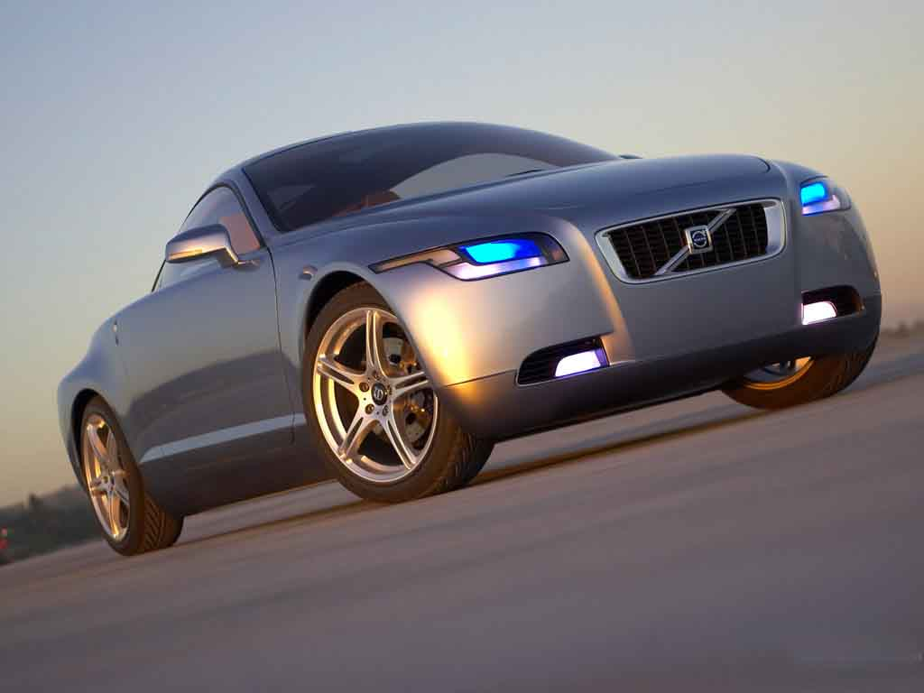

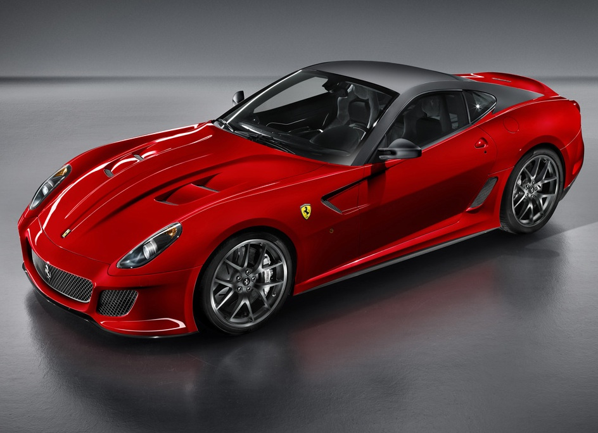



My Website

Cars production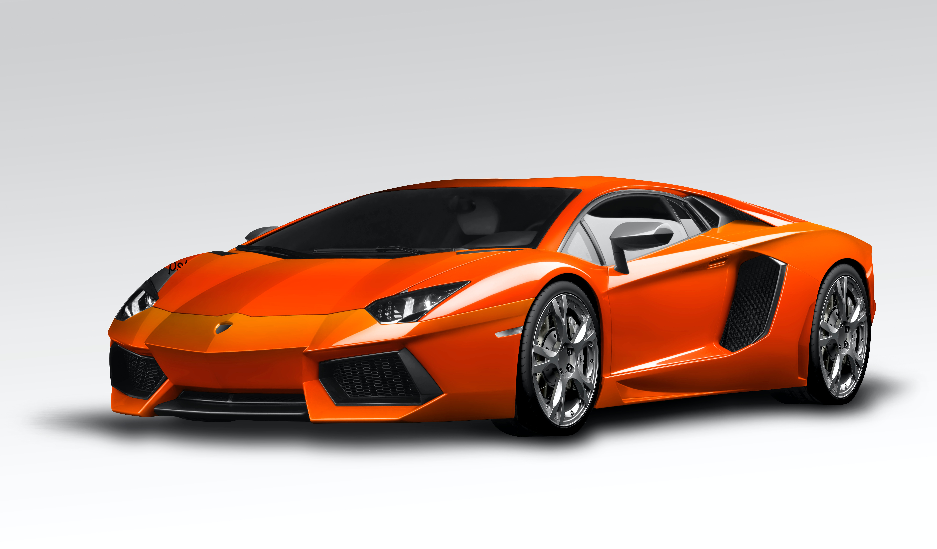

Cars production

1. Invention of the Automobile (Late 19th Century):
   * The concept of self-propelled vehicles dates back to the late 18th century, but the first practical automobile was developed in the late 19th century.
   * Karl Benz is credited with creating the first gasoline-powered automobile in 1886, known as the Benz Patent-Motor wagon. This three-wheeled vehicle had a single-cylinder engine and marked the birth of the modern automobile.
2. Early Developments (Late 19th to Early 20th Century):
   * In the late 19th and early 20th centuries, several inventors and engineers contributed to the development of automobiles.
   * Gottlieb Daimler and Wilhelm Maybach built the first four-wheeled automobile powered by a gasoline engine in 1889.
   * Henry Ford introduced the assembly line production system, making cars more affordable and accessible with the introduction of the Ford Model T in 1908.
3. Mass Production and Popularization (Early to Mid-20th Century):
   * The early 20th century witnessed the rise of numerous automobile manufacturers and technological advancements.
   * General Motors, founded by William C. Durant in 1908, became the world's largest automobile manufacturer.
   * Innovations such as electric starters, hydraulic brakes, and closed car bodies made cars more comfortable and reliable.
   * Ford's Model T, with its affordable price and robust construction, became immensely popular and transformed the automobile industry.
4. Post-World War II Developments (Mid-20th Century):
   * After World War II, the automotive industry experienced significant growth and technological advancements.
   * Car designs became more aerodynamic, and new materials such as fiberglass and aluminum alloys were used.
   * Innovations like power steering, automatic transmissions, and air conditioning were introduced, enhancing driving comfort.
   * European manufacturers like Volkswagen and Fiat gained prominence, and sports cars like the Chevrolet Corvette and the Ford Mustang became popular.
5. Modern Era (Late 20th Century to Present):
   * The late 20th century and early 21st century witnessed rapid advancements in car technology.
   * Fuel efficiency and environmental concerns led to the development of hybrid and electric vehicles.
   * Safety features like seat belts, airbags, and anti-lock braking systems (ABS) became standard.
   * Advancements in computer technology led to the introduction of electronic systems, such as advanced infotainment systems and autonomous driving features.
6. Current Trends:
   * Present-day trends in the automotive industry include the continued development of electric vehicles (EVs), self-driving cars, and connected vehicles.
   * Companies like Tesla have played a significant role in popularizing electric cars and accelerating the adoption of EV technology.
   * Many automakers are investing in autonomous driving technology to
   * create self-driving vehicles that offer improved safety and convenience
   * .